Name _______________________________________________
Homework Due Friday, November 9

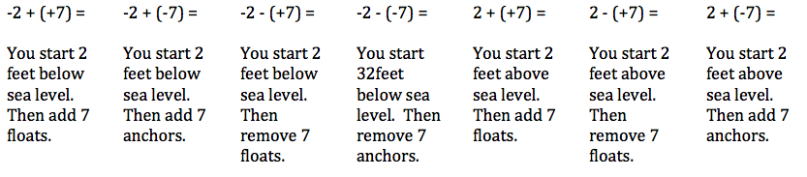
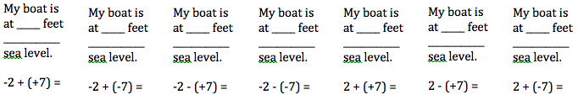

Write the numbers in order from least to greatest:
1) -9, 4, -5, 2

2) 10, 0 -3, -10

3) -7, 6, -8, 1

4) 3, -6, -4, 5

5) -2, -1, 9, -7

