AS YOU COMPLETE THIS REVIEW, BE SURE TO SHOW WORK FOR EACH QUESTION!

Learning Target 1.1: I can use the ratio of a circle’s circumference to its diameter to calculate pi. (7.3.1.1)

- Complete the chart. Round to the nearest tenth.

Diameter | Circumference | $$\frac{C}{D}$$ | C ÷ D | Radius
 |  |  | 3.14 | 8 cm
 | 47.1 cm
9 cm

- The circumference of a circle is about how many times greater than its diameter?

A.) 2 B.) 3 C.) 9 D.) 4

- The students in Mrs. Fernando’s math class wrote the following statements to help explain π.

I. π is the ratio of the circumference to the diameter of a circle.
II. π = 3.14
III. $π ≈ \frac{22}{7}$
IV. π is an irrational number

Circle any statements that are correct.

Learning Target 1.2: I can calculate the circumference of a circle. (7.3.1.1)

- If you walk around a circle that has a diameter of 200 meters, how far have you walked?

- What is the circumference of the circle below? (Use $π≈ \frac{22}{7}$)

A.) 22 in B.) 44 in C.) 88 in D.) 154 in

3. This wheel has a radius of 1.2 feet. What is its circumference?
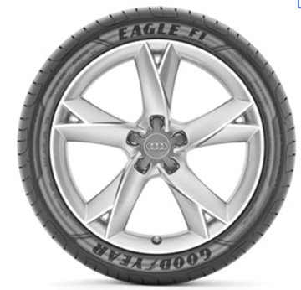

If there are 5,280 feet in 1 miles, how many times will the wheel have to turn around in order to travel 5 miles?

Learning Target 1.3: I can calculate the area of a circle. (7.3.1.1)

- What is the area of the following circle? (Leave your answer in terms of π.)
3 in

A.) 6π in² B.) 9π in² C.) 36π in² D.) 81π in²

- The diagram shows a semicircular carpet with a diameter of 7 feet. What is the area of the carpet? (Use $π≈ \frac{22}{7}$)

Learning Target 1.4: I can calculate the volume of a cylinder and justify its formula.(7.3.1.2)

- What is the volume of the cylinder? (Use π ≈ 3.14.)
3 mm
4 mm

A.) 12 mm³ B.) 37.68 mm³ C.) 75.36 mm³ D.) 113.04 mm³

- What is the volume of the cylinder? (Use π ≈ 3.14.)

2 in
10 in

Learning Target 1.5: I can calculate the surface area of a cylinder and justify its formula. (7.3.1.2)
- Find the surface area of the cylinders below. Round your answer to the nearest whole number.
(Use π ≈ 3.14.)

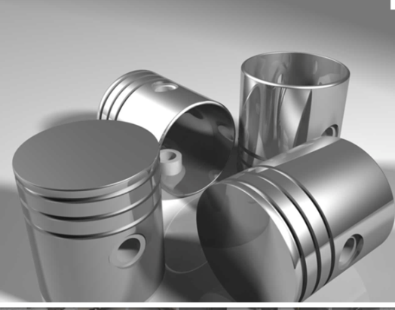
- The picture below shows pistons from a car engine. Each piston is a cylinder that has a radius of 3 centimeters and a height of 8 centimeters. What is the total surface area of each piston?

