Name _________________________________________________

Homework More practice with circles and cylinders due Friday, October 26
SHOW ALL WORK!

1.1 Relationship of pi
Diameter is 20 cm. The circumference is 62.8 cm. Find circumference divided by diameter.

Circumference Is 263.76 inches and the radius is 42 inches. Find the circumference divided by diameter.

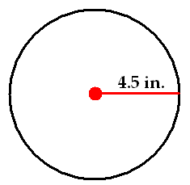
1.2 Circumference
Find the circumference of this circle.

A kids bicycle wheel is 12 inches across. How far will the bicycle go when the wheel goes around once?

A bicycle wheel is 20 inches across. How far can the bicycle go if the wheel goes around 20 times?

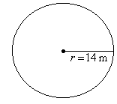
1.3 Area
Find the area of this circle.

A large pizza is 18 inches across. How much pizza will my family eat?

1.4 Volume
A can of diced tomatoes is 7 centimeters across and 12 centimeters tall. How much diced tomatoes can fit inside the can?

A really large can of diced tomatoes is 22 centimeters across and 30 centimeters tall. How much diced tomatoes can fit inside the can?

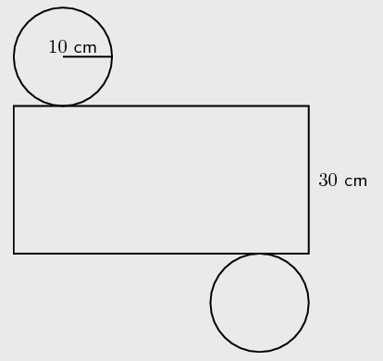
1.5 Surface Area
Find the surface area of the cylinder

A can of diced tomatoes is 7 centimeters across and 12 centimeters tall. How much material is needed to make the can?

A really large can of diced tomatoes is 22 centimeters across and 30 centimeters tall. How much material is needed to make the can?

