Name __________________________________________
Volume homework due Wednesday, October 3

Be sure to show work for each problem. NO WORK = 0 POINTS

Write the formula for calculating volume of a cylinder:

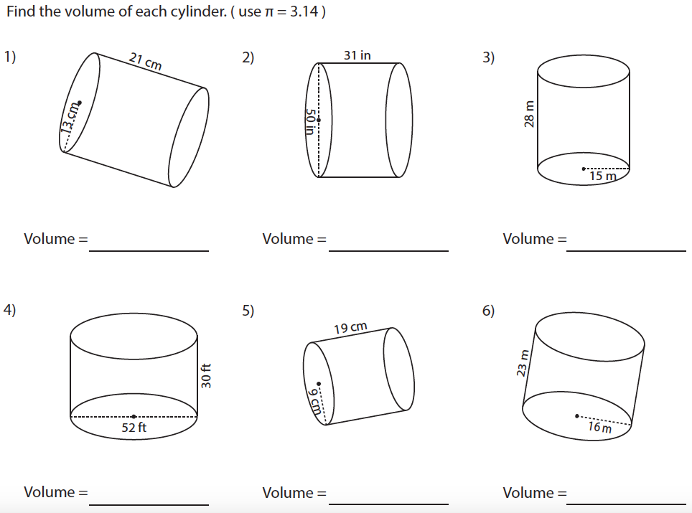

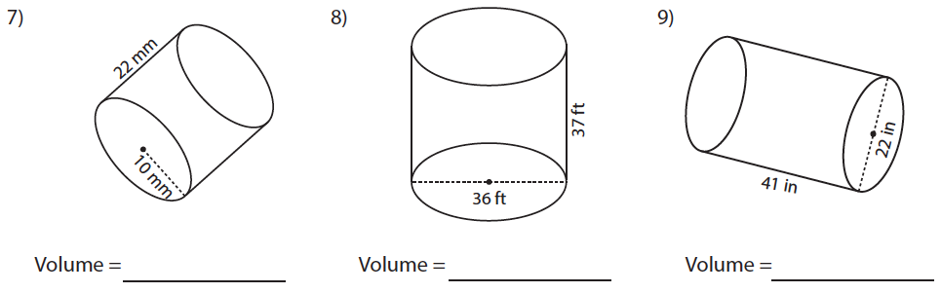

10) Find the amount of wax required to make a candle with radius 22 millimeters and height of 61 millimeters.

11) Find the volume of a cylindrical gas tank which is 5.5 feet long and has a base diameter of 2.8 feet.

12) A swimming pool with cylindrical base has a diameter of 21 feet and a depth of 5 feet. Find the volume of the pool.

